

**EXIM Thailand Finances Prima Marine Group to**

**Build Green Merchant Marine and Drive Blue Economy Development**

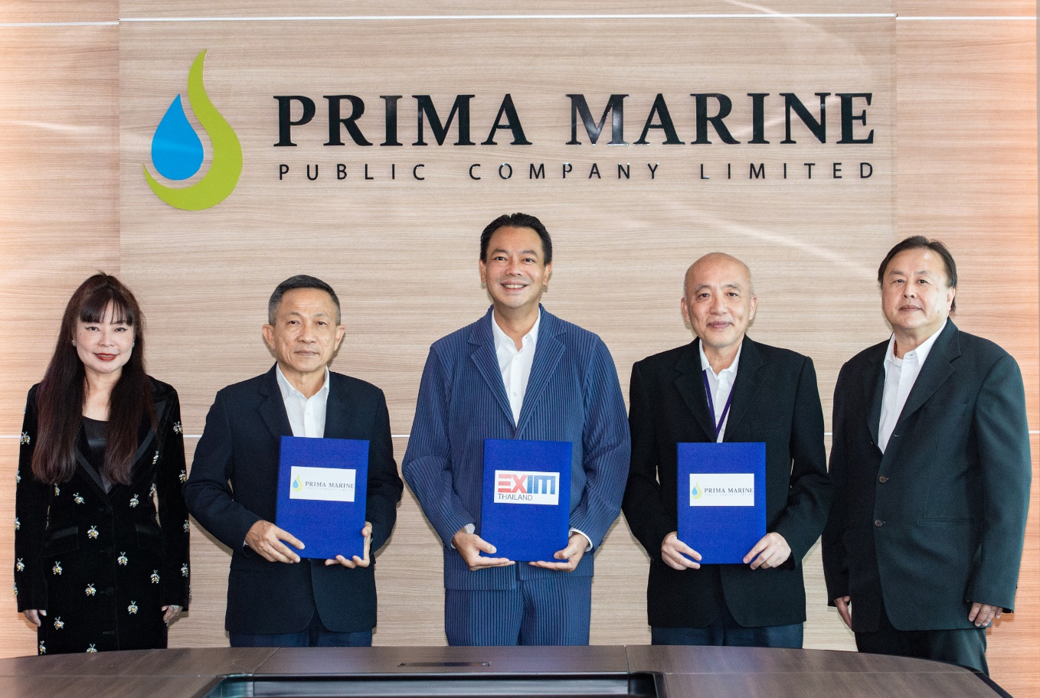

Dr. Rak Vorrakitpokatorn, President of Export-Import Bank of Thailand (EXIM Thailand), Mr. Prompong Chaisrisawatsuk, Chief Executive Officer and Chairman of the Board of Executives of Prima Marine Public Company Limited, and Mr. Suraphon Meesathien, Chief Executive Officer of Nathalin Company Limited, and Chairman of the Risk Management Committee and Member of the Corporate Governance and Sustainable Development Committee of Prima Marine Public Company Limited, recently signed an EXIM Thailand financial agreement to enhance the environmental sustainability and operational liquidity of Prima Marine at Prima Marine’s Head Office. This financial support, totaling 343 million baht, covers the maintenance of 26 ships, including the installation of the Ballast Water Treatment System, a technology that treats ship ballast water before releasing it into natural water bodies, ensuring the sustainable conservation of marine and coastal ecosystems. The support aims to boost the competitiveness of Thailand’s merchant maritime fleet on the global scale and advance the Blue Economy, in line with EXIM Thailand's aim to become the Green Development Bank to drive sustainable development with the goals of achieving carbon neutrality by 2030 and net zero emissions by 2050, ahead of Thailand's targets by 20 and 15 years, respectively.

June 4, 2024

**For further information, please contact Corporate Branding and Communication Department**

**Tel. 0 2169 9999 ext**. **4111-4**